Stronghouse in EU perspective
Learning from a Joint Research Center report
21-5-2020

A more effective use and adaptation of existing measures, strategies and instruments is important to Stronghouse. To that end we analyze their impact, starting with the measures, strategies and instruments developed or adopted by our partners. Meanwhile we review both relevant literature and policies for lessons learned, to ensure complementarity and to avoid duplication. In the following we analyze the review of financial and fiscal instruments across the EU. This review was recently published by the EU Joint Research Center (JRC). It provides both interesting lessons and a broader context for the Stronghouse project.

Energy renovation and public support
EU Member States deploy various public support instruments to support the transformation of the building sector. Energy renovations are needed to achieve the EU energy efficiency target for 2030 and the transition towards climate-neutral Europe by 2050. The JRC describes the energy renovation necessary to reach these goals as ‘various intervention measures on the envelope of a building and its technical systems resulting into significant energy efficiency improvements (…) these interventions may often be complemented with renewable energy technology installations.’

EU targets
The EU energy efficiency target for 2030 is of course at least 40% cuts in greenhouse gas emissions (from 1990 levels), 32% share of renewable energy and 32,5% improvement of energy efficiency. To this end, EU-wide annually 15 billion-euro in public resources are spent on energy renovation for all types of buildings. However, the effect of these investments is not yet enough to reach the Paris agreement goal of maximum 2 degrees Celsius. This is one of the reasons why Stronghouse wants to improve the effectiveness and enhance the impact of support measures.

Grants and subsidies
According to the JRC grants and subsidies are the most commonly used instruments to support energy renovation, also by individual homeowners. Advantages of grants and subsidies are that they can support the uptake of new promising technologies, can assist vulnerable groups and low-income households and can help to realize smaller projects that are not interesting for commercial lenders. However, the JRC also signals a number of challenges: grants are more suitable for individual interventions than integral energy renovation, grants are associated with bothersome application processes, are limited because of public budget restrictions and could attract free riders. For Stronghouse the potential to reach vulnerable groups and low-income householders is very important. We hope to improve the access to grants – learning from good practices by Orkney. Finally, we work on how grants can enable a more integral energy renovation.

Loans
The JRC sees loans as a more sustainable means of investment in energy renovation, especially for deep renovation projects which include multiple intervention measures. Challenges are of course the willingness and possibility of households to take (additional) debt and the limited engagement of financial institutions. The JRC sees solutions in Energy Performance Contracts (EPC), in which an energy services company (ESCO) uses the stream of income from cost savings to repay the costs of a project. A single contract and reduced risk for homeowners are advantages of EPC contracts, however it might be difficult to finance ESCO’s and performance measurement might be challenging. Stronghouse pools the knowledge and good practices in loan schemes. Stronghouse aims to develop or redesign loan schemes which overcome the challenges noted by the JRC. Also Stronghouse wants to develop digital instruments to measure the effect in CO2 reduction of the investments realized through these loan schemes.

Fiscal instruments
The JRC describes a number of fiscal instruments such as income tax credits / deductions, property taxation and VAT reduction. These instruments are of course important for individual homeowners and for Stronghouse. However the role of Stronghouse partners will be limited to disseminating knowledge about national fiscal instruments related to energy renovation.

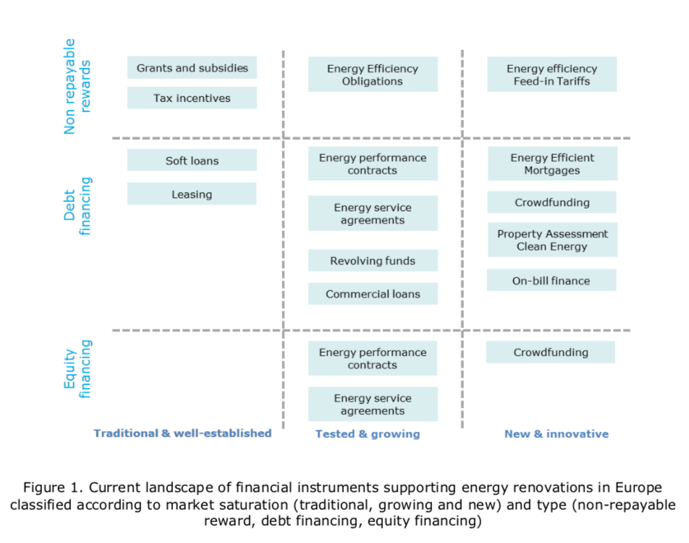
Figure 1 Appreciation of current financial instruments by the JRC

One-Stop-Shops
The EU asks Member States to consider advisory tools such as one-stop-shops to assist homeowners with energy renovation and relevant fiscal instruments. The JRC describes One-stop-shops as advisory tools that facilitate access to financial mechanisms, assist with technical and financial issues and guide them through key stages of the renovation process. One-Stop-Shops have many potential advantages. In Stronghouse the Linnaeus University shares its knowledge about One-Stop-Shops. Closely related to the One-Stop-Shop is the Customer Journey, which also identifies key stages of the renovation process and the support which homeowners in each step. ProjectZero shares its experience with customer journeys with other partners. Stronghouse works on the development of the One-Stop-Shop and Customer Journey models by creating a better understanding of homeowners’ need and interest and by re-designing elements of these One-Stop-Shops and Customer Journeys.

Private Financing Energy Efficiency
The JRC notes that financial institutions are becoming increasingly active with offers of specialized financial products focused on energy renovation: through commercial loans, energy efficiency mortgages, crowdfunding and energy cooperatives and energy efficiency insurance. Relevant for Stronghouse is how energy efficiency mortgages offer better borrowing terms for energy renovation. In the EU these mortgages are developed and piloted in the projects Energy efficient mortgages action plan (EEMAP) and Energy efficiency data protocol and portal (EEDAPP). Stronghouse is looking for cooperation with the plans. Also relevant for Stronghouse is how energy cooperatives engage citizens to support renewable energy projects and energy renovation. Here the experience of Drenthe and Noordenveld is especially relevant.

Sources:
https://publications.jrc.ec.europa.eu/repository/bitstream/JRC117816/accelerating_energy_renovation_investments_in_buildings.pdf

Hein Braaksma
Stronghouse

