### 

**Comparative Analysis of Maritime Spatial Planning (MSP) in the transnational setting of the North Sea: Explorative MSP Process Timeline**

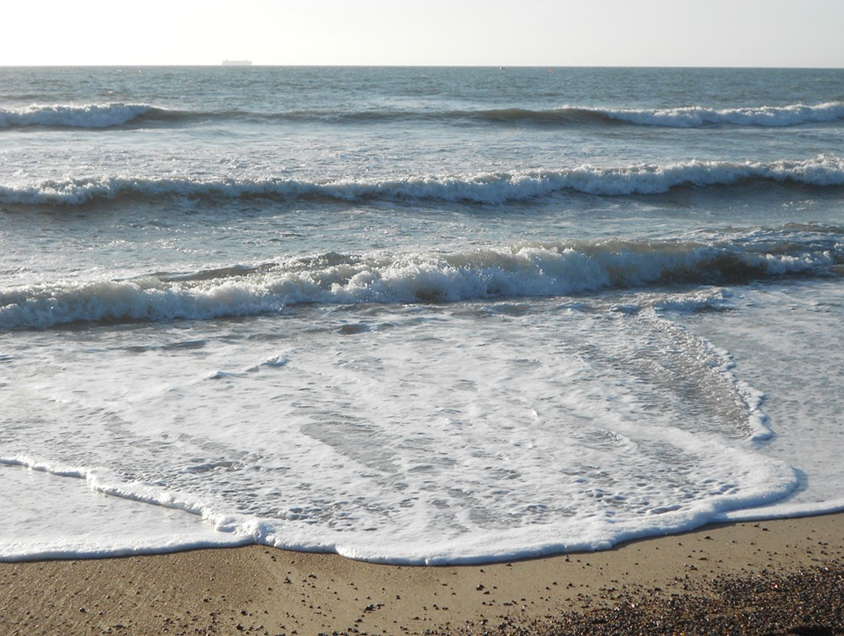

*By: Kirsty Wright*

*Project partner: Scottish Government*

*Date of publication: September 2018*

### Executive Summary

The North Sea is one of the busiest seas for maritime industries in the world. It’s shared resources represent a crucial asset, but also a shared territorial challenge to North Sea Region (NSR) countries, including Belgium, Denmark, Germany, Netherlands, Norway, Sweden, and the United Kingdom (England and Scotland). The EU Maritime Spatial Planning (MSP) Directive commits countries to have marine plans in place by 2021, and calls for transnational coherence. Some countries have yet to adopt their first national plan, whilst others are going through plan iterations. Progress mismatch and transnational incoherence are threats to the sustainable management of the North Sea.

A comparative analysis of MSP allows for inconsistences to be identified, knowledge transfer between planners, and is the first step to facilitate greater coherence and cooperation in marine planning. However, when undertaken in a transnational setting, it comes with additional challenges, such as different MSP approaches adopted between countries and differences in the terminology used.

This report presents the process and findings of undertaking a comparative analysis of the MSP approaches in NSR countries. Findings are presented using a communication tool, the “explorative MSP timeline”, developed as part of the European-funded NorthSEE project. More specifically, the tool:

* provides common terminology between countries, hence facilitating a better understanding of each other’s MSP processes;
* defines general steps in the MSP process; and
* visualises time overlap between MSP process steps, hence allowing for a forward look into the timing of MSP activities and better planning of transnational consultation between NSR countries.

**Contents**

Executive Summary 2

Introduction 4

Methods 5

Data collection 5

Comparative analysis 6

Tool design 7

Results 9

MSP Status and Progress 9

MSP Process Steps and Comparative Analysis 11

Generic MSP Process Steps 14

Visual Infographic of MSP Status 16

Discussion 18

Conclusion 19

### 

### Introduction

The North Sea Region (NSR) is one of the busiest areas for shipping and exploitation of natural resources (oil, gas, wind etc.) in the world, and contains unique natural reserves. Given the transnational nature of offshore activities and of marine ecosystems, facilitating coherence and cooperation in Maritime Spatial Planning represents a key shared challenge between North Sea Region (NSR) countries, including Belgium, Denmark, Germany, Netherlands, Norway, Sweden, and the United Kingdom.

Maritime Spatial Planning (MSP) has been identified as a main tool for implementing the EU Integrated Maritime Policy and is the central approach to give effect to the EU’s Blue Growth Strategy, while at the same time contributing to the achievement of Good Environmental Status in line with the Marine Strategy Framework Directive (MSFD). The EU MSP Directive requires all Member States to establish marine spatial plans by 2021. Although MSP is a national competency, the Directive calls for national plans to be coherent across sea basins and for Member States to cooperate on MSP matters.

The countries around the NSR are frontrunners when it comes to Maritime Spatial Planning. Most of them have implemented or are developing national Maritime Spatial Plans to promote sustainable development of the sea within their national boundaries. However, despite the existence of a number of international guidelines and experiences of Marine Planning, it still remains for each planning authorities to scope and develop their own planning methods and processes for MSP. This has led to countries adopting different processes and approaches to MSP, differences in terminology and progress mismatch. This unjointed approach threatens the sustainable development and management of the North Sea.

A comparative analysis of MSP is needed to identify synergies and incompatibilities, allow knowledge transfer between planners, and is the first step to facilitate greater coherence and cooperation in marine planning. The NorthSEE project: A North Sea Perspective on Shipping, Energy and Environmental Aspects in Maritime Spatial Planning aims to address this challenge. NorthSEE is an EU co-funded project which promotes a better exchange of information among MSP authorities, related experts and institutions in the NSR. It aims at achieving greater coherence in MSP across the NSR for three topics of transnational nature (organised as individual Work Packages; WP): Environmental aspects (WP3), Shipping routes (WP4), and Energy infrastructure (WP5).

The NorthSEE project aims to achieve:

* Greater coherence in Maritime Spatial Planning (processes) and in Maritime Spatial Plans (capturing synergies and preventing incompatibilies); and
* Creating better conditions for sustainable development of the area in the fields of shipping, energy and environment protection.

A recent output of the energy infrastructure work package was a status quo report on offshore energy planning provisions in the North Sea Region. A chapter in this report discussed the role of MSP for offshore energy developments and the background research involved a comparative analysis of the different MSP provisions of the NSR countries. A comparative analysis table was created, in addition to NSR country profiles which included the following topics: status of national marine planning, planning authorities, legislative framework and history of MSP, national policies and targets, planning responsibilities, planning and licensing procedures, consultation with stakeholders and spatial databases.

This report specifically focuses on the process and findings of undertaking a comparative analysis of the MSP processes in NSR countries. The focus on MSP processes was selected to increase the awareness and understanding of the different MSP processes across NSR countries and allow a knowledge exchange. This is a step towards alignment of MSP process and creating a joined-up approach to MSP in the North Sea.

MSP processes are explored in a timeline format for all NSR countries and the findings are presented using a communication tool, the “explorative MSP timeline”.

The aims of the tool are to:

1. provide a common terminology between countries, hence facilitating a better understanding of each other’s MSP processes;
2. define general steps in the MSP process – different MSP processes exist across the NSR countries. Having these steps will allow country-specific MSP process steps to be categorized under general steps; and
3. visualise time overlap between MSP process steps, hence allowing for a forward look into the timing of MSP activities and better planning of transnational consultation between NSR countries.

The target audience of the report includes marine planners at National MSP authorities in the NSR, European Institutions (e.g. European Commission’s Department for Maritime Affairs and Fisheries, The Conference of Peripheral Maritime Regions (CPMR) North Sea Commission etc.), local authorities, energy developers, and Non-Governmental Organisations, together with their advisers, institutes of higher education and other scientific bodies involved in the field of maritime spatial planning.

The report also serves as an output of the NorthSEE consortium. Outputs of this report act as an exploratory approach to harmonizing MSP processes and visualizing the MSP status of NSR countries. The report provides marine planners with suggestions and future recommendations to help facilitate transnational cooperation between NSR countries.

### Methods

This report focuses on gaining two aspects of MSP information from NSR countries in order to explore, analyse and compare MSP processes:

1. Current MSP status – where countries are in their planning process and what activities they are currently doing; and
2. MSP process steps – each countries planning process from start (No MSP existing) to implementation of their MSP, including any future plans.

Data collection

Information on the MSP process was collected from each NSR partner (Belgium, Denmark, Germany, The Netherlands, Norway, Sweden and Scotland). Firstly, a timeline from January 2017 until December 2022 which showed a snap-shot of the current status of MSP and also countries future MSP plans. In order to determine countries current MSP status, the following information was taken into account; whether or not MSP was in place, current MSP round e.g. revision or planning cycle/loop and current MSP activity e.g. pre-planning, consultation, draft, approval etc. This information was collated into an overview ‘Gantt chart’ format timeline including all MSP process for each NSR country. Secondly, information on the MSP process from start up until final MSP implementation. Key steps were then selected out of each countries MSP process creating a broken-down, simplified version of their processes.

Comparative analysis

The simplified versions of the different MSP processes allowed for an easier comparison between the NSR countries. The following aspects of the MSP processes were compared: steps involved, number of steps, order of steps and terminology used. In addition to comparing and analyzing the NSR countries MSP processes, other MSP process steps were reviewed such as UNESCO’S step-by-step approach (Ehler and Douvere, 2009) and project defined steps such as those in Plancoast and Balt Sea Plan. These guides contain a number of planning principles and approaches for the development of successful MSP initiatives.

Marine spatial planning processes have been described in many different ways, however they all share common elements and process steps. A cross comparison of the common elements and the principles and approaches was undertaken to ascertain a set of core MSP process steps. This combined an evaluation of the simplified steps, the other MSP steps and the terminology used in each of them, initially creating 12 ‘generic’ steps. Each of these steps had a description in which sub-steps were included. In order to design the process, the following principles described by Stojanovic, T. A 2017[1] were used:

1) Logic of precedence

2) Logic of importance, and

3) Logic of context.

The sequence of steps was then re-ordered according to these logics.

In order to test the ‘generic steps’ were fit for purpose, a process matrix was drawn up to match the newly created ‘generic’ steps and the individual countries simplified steps. The steps were then refined in consultation with project partners from all North Sea Member States. Partners were tasked with an exercise to try and match up their own MSP steps with the general steps by drawing links to the ‘generic’ steps they thought best matched their own MSP steps. The feedback from this exercise was then fed into a revision of the ‘generic’ steps and a list of agreed terminology definitions. Partners were also consulted upon the ‘generic’ steps through a series of targeted questions:

1. Do you agree with the order of the generic steps? If not, what would you change?
2. Do you agree with the terminology used? If not, what terminology would you use?
3. Are any steps missing and if so, what steps would you add?
4. Where is your country currently in their MSP process? (first time plan, second revision, third revision? And what activity are you currently doing; consultations, data collection, revisions?)

The questions acted as confirmation that partners were content with the terminology and order of the ‘generic’ steps. Feedback from the partners matching exercise and questions were fed into the revision of the ‘generic’ steps and they were then finalised. The finalised steps did not include numbers to emphasize that they are not necessarily in that order and can be interchangeable. Other steps also ran in parallel to other steps throughout the process. Two versions of the final ‘generic’ MSP steps were created: a version including the main steps and the sub-steps and a simplified version just including the main steps.

The newly formed ‘generic’ steps represent the start of the MSP process where there is no MSP existing. For countries who haven’t yet implemented MSP, this forms a guideline and for other countries who are on several iterations of their MSP, it forms a ‘tool’ to track country MSP status.

Tool design

Many MSP guidelines present diagrams of general marine planning processes (see annex). These are all displayed in different formats where some might be described as ‘linear and logical’ series of steps or stages to planning, or some as planning ‘cycles’ or ‘loops’. NSR countries initially provided their MSP process in a timeline format where the thoughts associated with the word ‘line’ are of a linear format, in practice however, stages will be done out of step, repeatedly or in parallel, and that the planning process does not work in isolation but is influenced by wider planning and political initiatives. It was therefore decided that the process wasn’t a series of steps (some countries had different order) but a cycle or loop of steps where some steps ran in parallel to other steps or ran throughout the process. On this basis, a final infographic was designed, creating a visual tool. Countries flags were position on the infographic to represent their current MSP status. This tool will allow for an easier comparison between the countries and aids visualisation of the different stages that countries are in their MSP process.

Table 1. Exploration and comparison of other MSP process steps for common elements.

|  |  |  |  |
| --- | --- | --- | --- |
| UNESCO steps | | Plancoast steps | BaltSea Plan steps |
| 1 | Identify need and establish authority | Getting organised | Starting the process - assessing need and will undergo MSP process |
| 2 | Obtain financial support | Laying the ground for MSP | Defining a vision, planning principles, legal framework and strategies |
| 3 | Organise the process through pre-planning | Assessing the context and establishing a general framework for MSP | Undertaking initial stocktaking and systematic assessments of suitable areas for relevant uses |
| 4 | Organising stakeholder participation | Drawing-up a guiding vision | Finding out compatibilities and conflicts, mapping and analysis |
| 5 | Defining and analysing existing conditions | Refining the stocktake and mapping | Drafting MSP and environmental report |
| 6 | Defining and analysing future conditions | Identifying issues and problems | Stakeholder engagement and consultation |
| 7 | Preparing and approving the spatial management plan | Developing solutions for the problems identified | Producing final MSP and zoning plan including regulations for management and final stakeholder comments |
| 8 | Implementing and enforcing the spatial management plan | Drawing up a plan | Adopting the plan and organising implementation |
| 9 | Monitoring and evaluating performance | Implementation | Monitoring plan implementation and its effects |
| 10 | Adopting the marine spatial management process | Evaluating and reviewing | Revision and adjustment of the plan - take account of changes and monitoring results |

### Results

MSP Status and Progress

The nations bordering the North Sea are developing MSP to fulfil their requirements under the EU Directive for MSP, to deliver maritime spatial planning by March 2021. NSR countries are in different stages in MSP development. Most NSR countries have had at least one version of a statutory national marine plan adopted. Figure 1 shows countries including Belgium, Netherlands, and Germany are already in the process of revising their national MSP. Others, such as Denmark and Sweden are in the process of establishing a marine plan for the first time.

In order to understand countries current MSP status and put it into context, a planning loop/cycle visual aid was created. Figure 2 shows the flow from no MSP existing, through the MSP process planning loop/cycle to several revisions of the MSP. Partners were asked to identify their current MSP round and MSP activity and this information was fed into Table 2.

Table 2 shows that Norway has made the most progress and are further ahead in their MSP process. However, since Norway is not an EU Member State, they have a process equivalent to MSP. In terms of EU Member States where MSP is comparable, The Netherlands have made the most progress and Denmark have made the least progress in their MSP.

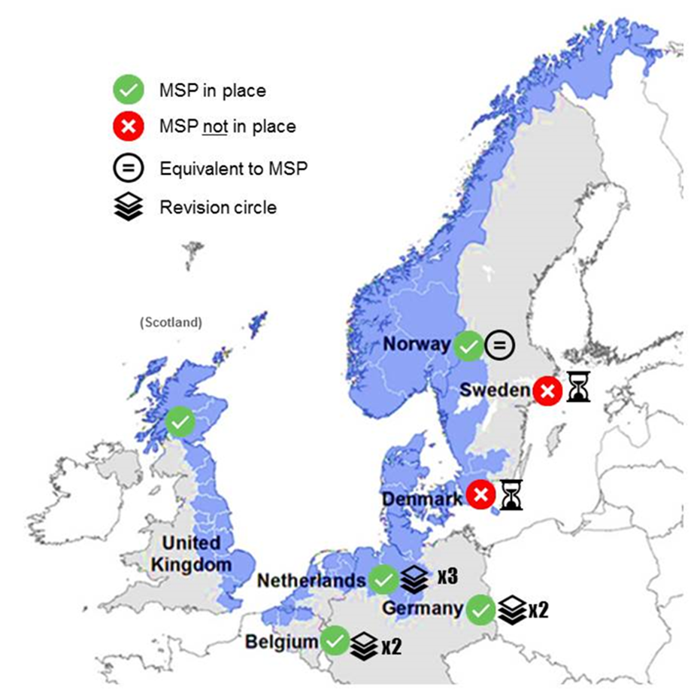

Figure 1. Status of MSP in NSR countries. This infographic highlights the progress mismatch in MSP amongst NSR countries.

|  |  |  |  |
| --- | --- | --- | --- |
| Country | Current MSP existing (Y/N) | Current MSP Round | Current MSP Activity |
| Belgium | Yes | 2nd plan revision, 3rd cycle | Almost finished first draft of revised plan and about to present plan to the Minister for their first approval |
| Denmark | No | 1st cycle, no plan yet |  |
| Germany | Yes | 1st plan revision, 2nd cycle | Pre-planning phase - Evaluating current MSP plans |
| Norway | Yes | 5th plan revision, 6th cycle | Identification of new information phase |
| The Netherlands | Yes | 3rd plan revision, 4th cycle | Pre-planning phase |
| Scotland | Yes | 1st plan revision, 2nd cycle | Just completed consultation on 1st plan revision. No amendments required. |
| Sweden | No | 1st cycle, no plan yet | Preliminary plan and first consultation |

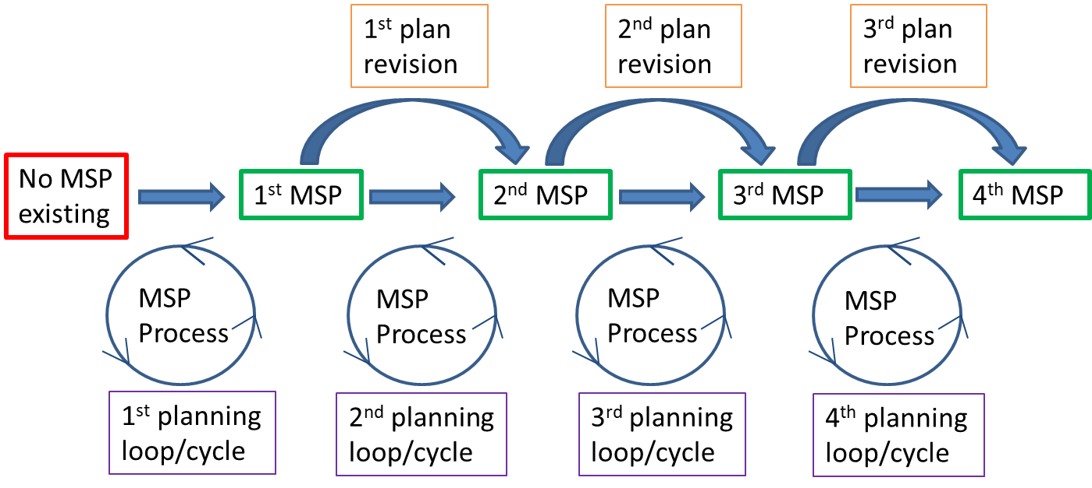

Figure 2. Flowchart showing progression from starting MSP to several revisions of MSP.

Table 2. Current MSP status of North Sea Region countries (as of March 2018)

MSP Process Steps and Comparative Analysis

In order to carry out a comparative analysis of NSR countries planning processes, common elements and differences were identified. This involved an in-depth look into for example, the order of steps, number of steps and terminology. In terms of planning processes, it appeared that Germany has a very long and detailed MSP process where as in contrast, Scotland has a much more short and simplified process. However, this is purely based on the information and level of detail that countries provided on their MSP. This information does not represent verified MSP criteria.

Firstly, the common elements across all NSR planning processes were identified. This showed that all countries planning processes contained key MSP criteria and they also followed the same logical or hierarchical order of main planning steps. All countries also hosted consultation and participation opportunities for stakeholders (members of the public and scientific experts) and carried out an SEA under EU legislative requirement at some point in their process.

Secondly, the differences identified between NSR country planning processes included differences in the timing of stakeholder consultations and of SEA processes. Consultations differed in their timing within the process and with participants. Some were generalised as ‘stakeholder’ consultations but others specifically focused on public consultation or consultation with scientific experts. Only Belgium’s and Germany’s MSP process mentioned international or transnational consultation and Belgium also send copies of their final MSP to their neighbors. For SEA processes, the timeline format suggests that countries such as Scotland and Belgium carries out this process near the beginning, Denmark and Germany towards the end, and Norway, Sweden and The Netherlands throughout the MSP process. There were also differences in focus and approach of planning processes, for example Norway adopts a sectoral approach to marine planning with a main focus on industry such as maritime transportation, fisheries and oil. It was found that there was limited reference of transnational consultation in planning processes where this was only mentioned in Belgium and Germany’s planning process. There was also limited reference to future planning where this was only referred to in Denmark and the Netherlands planning process.

Terminology differed between the MSP processes of countries in both word choice and meaning. This is expected with the different languages around the NSR, however English is used as a common language. However the words ‘Scoping’ and ‘Proposal’ caused some confusion as they had a different meaning across different countries. The terms ‘statutory’ and ‘non-statutory’ which are used in the consultation process of the Scottish MSP system to differentiate between stakeholders which need to be consulted on planning applications by law and those not required by law were found to only be applicable in the UK and therefore it wasn’t relevant for the ‘generic’ steps.

The following tables display a comparative analysis of all NSR countries maritime planning process and also of the three case study planning processes; UNESCO, Plancoast and BaltSeaPlan. The tables highlight the key points for comparison which are as follows:

Table 3. Comparative analysis of MSP process case studies

|  |  |
| --- | --- |
| **MSP process case studies** | **Key points for comparison** |
| UNESCO step-by-step | * Contains key MSP criteria * Adopts a hierarchical approach to marine planning * Recognises need for financial support |
| Plancoast | * Contains key MSP criteria * Adopts a hierarchical approach to marine planning * Focus on issues and solutions |
| BaltSea Plan | * Contains many of the key MSP criteria * Regional planning approach and zoning * Addresses issue of transnational cooperation * Adopts a hierarchical approach to marine planning |

Table 4. Comparative analysis of NSR country MSP

|  |  |
| --- | --- |
| **NSR Country MSP** | **Key points for comparison** |
| Belgium | * Plan successfully implemented * Large focus on consultation with neighbouring countries – transnational consultation, translation of MSP to French and English and sending copies of plans to neighbouring countries |
| Denmark | * Plan not yet implemented * Focus on data collection and MSDI database * Blue growth potential * Takes into account climate change * Focus on 2030 and 2050 vision * Designation of areas |
| Germany | * Contains many of key MSP criteria * Based in EU legislative framework * Contain specific actions relating to strengthening the German Maritime Economy through rational use of marine space * Focus on national and international consultation and participation with public and scientific council * International comparison and analysis of previous and current projects work |
| The Netherlands | * Contains many key MSP criteria * Plan successfully implemented * Future focus of offshore wind energy - 2023-2030 roadmap * North Sea Strategy with 2030 objectives and visions |
| Norway | * Contains many key MSP criteria * Plan successfully implemented * Plan specifically deals with issue of user conflict * Sectoral focus * Inclusion of climate change and related impacts |
| Scotland | * Contains many key MSP criteria * Plan successfully implemented * Regional planning approach |
| Sweden | * Plan not yet implemented * Simplified process * Focus on digital presentation of MSP |

Generic MSP Process Steps

The matching exercise where partners matched up their MSP process with the generic steps showed that the generic steps were largely fit for purpose as they included most of the key steps and followed a similar order to countries current MSP process. It was decided that the following steps ran in parallel or occurred throughout the process: stakeholder consultation & participation, SEA/EIA process and MSFD. Feedback from the partners showed that there was general consensus on the generic steps, the order of the steps and the terminology used. There were only a few country-specific comments and requests for extra steps or re-ordering which were accommodated.

The agreed generic steps were displayed in two formats; a simplified version and an expanded version. The simplified version shown in Figure 1 shows only the major phases and the expanded version shown in Figure 4 details all of the sub-steps under each of the major phases.

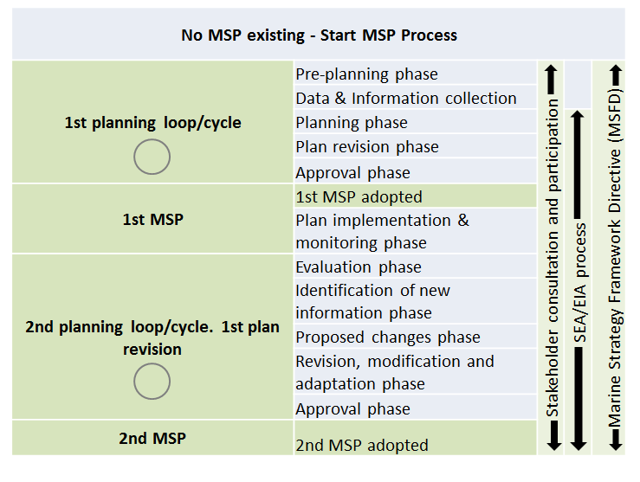

Figure 3. Simplified generic MSP process steps.



Figure 4. Expanded generic MSP process steps detailing sub-steps.

Visual Infographic of MSP Status

The final agreed generic MSP process steps were incorporated into the planning loop/cycle part of the flowchart shown earlier in Figure 2. As seen in Figure 5, all of the phases are placed in the loop/cycle and the stakeholder consultation & participation and SEA/EIA process phases are situated in an inner loop/cycle to represent their occurrence throughout the process. The starting location is the pre-planning phase of the first planning loop/cycle and once that is completed, the first MSP is created. This then continues into a series of plan revisions and multiple planning loops/cycles as countries progress further into their MSP.

In order to visualise the current MSP status of NSR countries, the information from Table 2 was used to place countries on the infographic. Country flags were used to indicate the specific activity they were doing when the information was collected in March 2018.

Figure 5. Infographic showing the generic MSP process steps and the current MSP status of North Sea Region countries (as of March 2018).

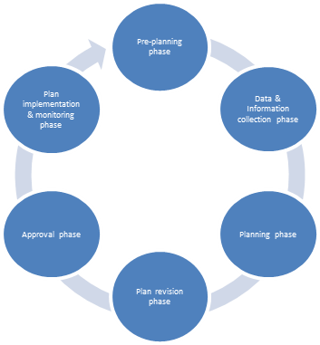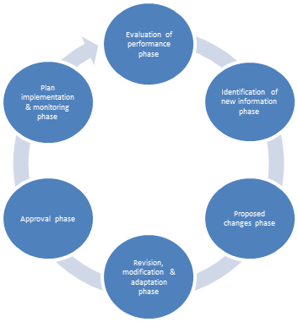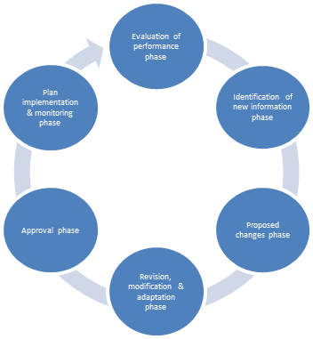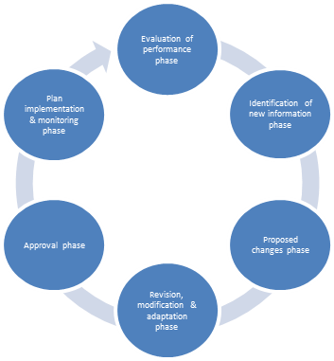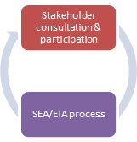

1st MSP

2nd MSP

3rd MSP

4th MSP

1st plan revision

2nd plan revision

3rd plan revision

1st planning loop/cycle

2nd planning loop/cycle

3rd planning loop/cycle

4th planning loop/cycle

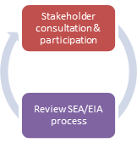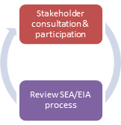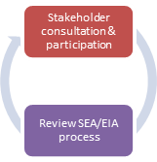

Start here!

### Discussion

NSR countries are all at different stages of MSP, despite an implementation deadline of 2021. Overall, MSP practices in NSR countries are well rooted in national legislation, with country-specific institutional frameworks in place. Current structures reflect traditional planning procedures as well as national needs and priorities. Currently Denmark and Sweden have yet to implement MSP but after 2021, all countries will have an MSP in place. Due to other countries such as The Netherlands and Germany being on several revisions of their MSP, progress mismatch will still be issue. Despite countries not being on an even playing ground, all EU member countries will have an MSP and MSP will be implemented throughout the North Sea and there will be opportunities for transnational coordination and cooperation.

The MSP Directive calls for coherence across all EU Member States plans which may explain the common elements found across all NSR countries MSP processes. Coherence in steps may also be due to adherence to EU legislation, for example, the requirement to carry out a SEA or follow the MSFD.

It is understood that MSP processes don’t necessarily need to be harmonized but they need to be compatible. However, there may be no right way to do MSP and instead, MSP is country-specific and dependent on various factors. These could include a range of factors such as size of marine area, access to natural resources, available space for development, activities, marine environmental considerations, economic and socioeconomic etc. There is no ‘one size fits all’ MSP process.

There are also lots of MSP process examples which have been published by various sources. For example, UNESCO’S step-by-step approach (Ehler and Douvere, 2009). Most countries in the North Sea also already have established MSP and have no reason or want to change it. However the aim of this exercise was not to re-do another MSP process or expect countries to change their MSP process, instead it was a learning and knowledge share process specifically targeted at NSR countries. In the future, there may be the drive to develop common criteria to implement coherence and also to raise the overall quality of MSP in the North Sea. The main desire was to explore the planning processes of NSR countries to find common elements and to facilitate understanding across NSR countries of each other’s MSP processes. Countries had to work together and agree on a set of common, ‘generic’ steps which they felt were fit for purpose and represented their MSP process. The generic MSP process steps also form a framework for countries such as Denmark and Sweden who haven’t yet implemented MSP to follow and learn from their North Sea neighbours. Exchange of the different approaches can also serve as a source of inspiration for improving national MSP processes. Furthermore, exchange can improve mutual understanding of the different national MSP systems and hence facilitate coordination.

It was expected that there would be differences in the terminology used between countries as there are several different languages spoken around the NSR. However, English is used as a common language and therefore it was agreed that the tool should be created in English. Although it was deemed important to clarify and define the terms as some countries translated the words differently or had different meanings for them. The solution was to create definitions and agree these with all countries.

The issues and limitations of this exercise and tool include the difficulty in comparing different MSP processes that are at different stages and timescales, or in Norway’s case, are equivalent to MSP. There were also different levels of detail and information supplied by countries which may affect the comparison. There was also an issue with trying to set timescales against each activity in order to fully understand the timeline of the process, this was specifically challenging for countries with MSP already established. Information was not always easily accessible and therefore there was a high dependency on the project partner for information. The limitations of the tool are that its static in time and will quickly become out-of-date as countries progress with their MSP. It also involves a highly labour and resource intensive data collection which many countries cannot afford the time and resources for. This led to a lack of appetite for the progression and future use of the tool as it requires commitment in the form of continuous maintenance. Also unlike the VASAB MSP planning platform for the Baltic Sea, there is also no equivalent platform for the North Sea. This relates back to one of the conclusions of the energy status quo report where an over-arching MSP body or mechanism for the North Sea is needed beyond the lifetime of the NorthSEE Project (end date is July 2019). However a positive aspect of this work is that a concept has now been developed and a common knowledge and terminology shared which means there is potential scope for the future. This work can be built upon in the future when better cooperation and coordination mechanisms exist or there is better commitments to coordinate MSP. For future institutionalised cooperation, the timeline exercise could be integrated and be further developed into a more active tool, also benefiting the MSP authorities directly. As it stands, the NorthSEE project aims to address these challenges but need mechanisms in place beyond the project’s lifetime

### Conclusion

In conclusion, the aim of this work was to improve transnational cooperation and coordination and aid knowledge exchange in MSP between North Sea countries. We defined general MSP steps and common terminology tailored to North Sea countries and displayed it in a user-friendly, visual format. This is an explorative concept tool with potential scope for the future, however there needs to be more commitment and proactive management from North Sea MSP authorities to coordinate MSP.

1. Stojanovic, T.A. (2017) Scoping the design of a regional marine planning process. A report to the MASTS Marine Planning and Governance Forum. June 2017.