**Hydrogen Supply Chain Map for the North Sea Region**

March 2018

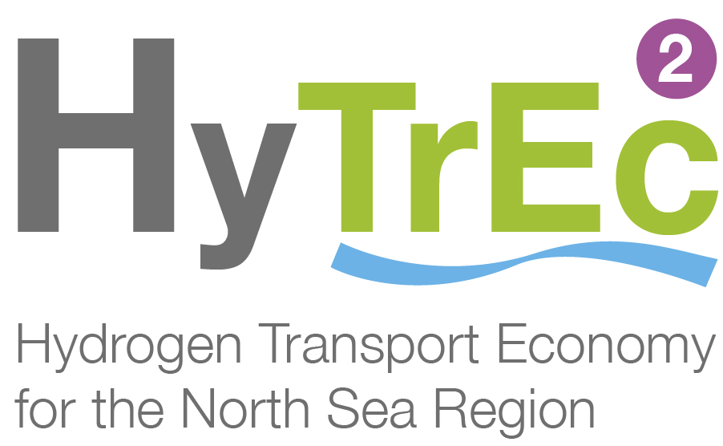ontents

Hydrogen Supply Chain Mapping Report

March 2018

|  |  |  |
| --- | --- | --- |
| Document Summary | | |
| **Client** | Aberdeen City Council | |
| **Project Title** | Hydrogen Supply Chain Mapping | |
| **Title:** | Hydrogen Supply Chain Mapping Report | |
| **Date of Issue:** | 17/05/18 | |
|  | **Name** | **Role** |
| **Prepared by:** | C Hartley | Business & Marketing Co-ordinator |
| **Approved by:** | T Dumenil | Senior Energy Consultant |

|  |  |  |  |  |  |
| --- | --- | --- | --- | --- | --- |
| Amendment Record | | | | | |
| **Rev** | **Date** | **Description** | **Issued By** | **Checked By** | **Approved By** |
| V01 | 1/3/18 | Draft | C Hartley | S Gomersall | T Dumenil |
| V02 | 16/05/18 | Client feedback | C Hartley | S Gomersall | T Dumenil |
|  |  |  |  |  |  |
|  |  |  |  |  |  |

**Disclaimer:**

While the authors consider that the data and opinions contained in this report are sound, all parties must rely upon their own skill and judgement when using it. The authors do not make any representation or warranty, expressed or implied, as to the accuracy or completeness of the report. The authors assume no liability for any loss or damage arising from decisions made on the basis of this report. The views and judgements expressed here are the opinions of the authors and do not reflect those of the client or any of the stakeholders consulted during the course of this project.

## Table of Contents

Contents 2

1.0 Executive Summary 5

2.0 The Hydrogen Opportunity 7

3.0 The Hydrogen Supply Chain 12

4.0 Hydrogen Supply Chain Growth 27

5.0 Glossary 30

6.0 References 31

## Figures

Figure 2‑1: Scottish split of total energy consumption, (Scottish Government, 2015) 7

Figure 2‑2: The UK seasonal demand for electrcity and low grade heat (Energy Technologies Institute, 2015) 8

Figure 2‑3: The UK winter peak heat demand profile (Energy Technologies Institute, 2015) 8

Figure 2‑4: Hydrogen production storage and use (Aberdeen City Council, 2015) 10

Figure 3‑1: Supply Chain Map (Pale Blue Dot Energy, 2018) 14

Figure 4‑1: Diversification pathway (Pale Blue Dot Energy, 2016) 28

## Tables

Table 3‑1: Hydrogen supply chain elements 21

Table 3‑2: Generic hydrogen supply chain 26

# 

# Executive Summary

This report provides a breakdown of the hydrogen supply chain, with a focus on transport and considers means to engage and grow hydrogen activity. The material has been developed and presented in a way which could also be used to inform and engage the supply chain directly.

A detailed hydrogen supply chain map has been prepared as a basis for assessing and developing hydrogen supply chain engagement for North Sea HyTrEc2 regions.

The regions could develop strong hydrogen supply chains building upon existing hydrogen transport activity and regional supply chain capabilities.

Increasing activity levels are key to growth; this will reduce the cost of hydrogen and increase supply chain opportunities.

Some of this increased hydrogen activity will come from non-transport activity such as heat and power.

Potential exists for HyTrEc2 partners to develop further collaborative activity for example related to stimulating hydrogen vehicle uptake, supply chain engagement best practice and hydrogen ships.

The work has been funded by Interreg North Sea Region and Aberdeen City Council and motivated by the Hydrogen Transport Economy in the North Sea Region (HyTrEc2). The HyTrEc2 partners are; the European Institute for Innovation Technology e.V., Aberdeen City Council, Centre of Excellence for Low Carbon and Fuel Technologies, Hogskolen i Narvik, SP Sveriges Tekniska Forskningsinstitut, Provincie Drenthe, Gemeente Groningen and Aberdeenshire Council. This report has been prepared by Pale Blue Dot Energy.

The Hydrogen Council believes that by 2050 18% of global energy demand will be hydrogen based; it will have a value of $2.5trillion and support 30 million jobs (Hydrogen Council, 2017). Opportunity exists now for HyTrEc2 North Sea partners, including the Aberdeen region, to engage their supply chains and ensure they play a major part in the emerging global hydrogen sector.

This study has broken down the hydrogen supply chain to a detailed 3-tier level under the supply chain elements of production, movement, storage, transport applications and support services. In addition, the supply chain for non-transport applications has been developed to a 2-tier level. There is little previous analysis of the hydrogen supply chain in the UK, yet such an understanding is important for sector growth.

Four ways to support regional supply chain growth are identified:

* growing existing regional hydrogen supply chain businesses;
* diversifying existing regional companies into hydrogen;
* bringing existing hydrogen players to the region and;
* stimulating new hydrogen businesses in the region.

Further studies could be developed with HyTrEc2 North Sea partners to address aspects of the emerging hydrogen market, such as:

* application of hydrogen for ferries and ships;
* development of commercial models to stimulate uptake of hydrogen vehicles;
* the process and experience of supply chain engagement.

Whilst local hydrogen transport projects provide visibility of the hydrogen opportunity, supply chain engagement needs wider hydrogen activity and more projects. Increased activity is also key to reducing costs, including the price of hydrogen. Whilst some of these projects will be in the local region, supply chain growth requires clarity of direction at national and EU level and engagement of the local supply chain in national and international opportunities.

Significant opportunity will arise from non-transport hydrogen applications, especially for heat. This will include the production of hydrogen from natural gas, with carbon capture and storage to mitigate the CO2 emissions of the process. Development of non-transport applications has the potential to significantly increase the value of hydrogen supply chain activity.

# The Hydrogen Opportunity

In 2015, at the 21st Conference of the Parties in Paris, 195 countries signed a legally binding agreement to keep global warming “well below 2°C above pre-industrial levels”. Achieving this target will require a monumental change in the way we use and consume materials and energy. There is no single technological advance or energy vector that can tackle this issue. A combination of energy efficiency, renewable and low carbon energy is required.

To begin to begin to understand the role of hydrogen for Europe and specifically for North Sea Regions we need a simple high-level understanding of how energy is used today. Most people associate energy and carbon emissions with electrical power generation.

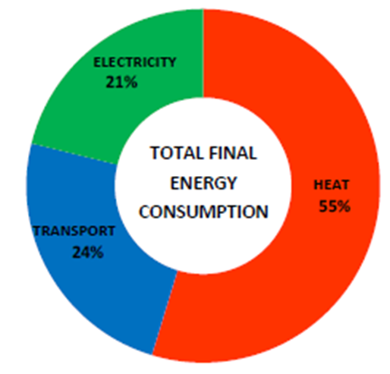

Figure 2‑1: Scottish split of total energy consumption, (Scottish Government, 2015)

Figure 2‑1, provides a breakdown of electricity, transport and (non-electric) heat for Scotland. This split is generally representative of other North Sea Countries, where the northerly latitude requires considerable energy be used for heating.

It shows that electricity makes up just over a fifth of total energy consumption. Transport, predominantly in the form of diesel or petrol, makes up a quarter of total energy consumption whilst over half is for heating which, for most North Sea countries, is currently delivered via natural gas or heating oil. Thus, around 75% of current energy demand is fossil fuel. By 2050, based on current legislation, over 80% of total energy use will need to be delivered without the release of carbon emissions.

Europe’s current and potential abundance of renewable energies will play a significant role in the provision of primary energy for electricity, transport and heat. However, this can only be achieved through major investment in infrastructure in electrical grid reinforcement and evolved energy storage technologies to balance the intermittency of generation and fluctuation of user demand, specifically for heat as shown in Figure 2‑2 and Figure 2‑3. Whilst the UK and Northern European demand for electricity and transport are relatively stable across the year, a seasonality factor of circa 6 applies to heat. This is compounded by the daily profile for heat demand with a peak load factor of 19 compared to the night time base load. For example, to fully electrify the current UK gas demand would require an extra 321TWh of electrical generation or 12 new Hinkley C power stations. In addition, the electrical grid would require reinforcement or replacement to cater for the daily and seasonal variation in demand.

Our currently dependence on hydrocarbon fuels for heat and transport has, in part, evolved from the ease of which they can be transported, stored and converted at the point of use. Hydrogen can deliver these same advantages going forward but without the carbon impact.

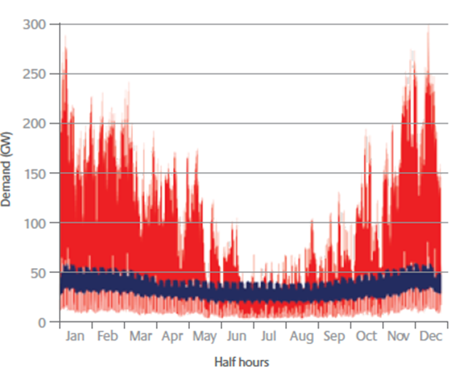

Figure 2‑2: The UK seasonal demand for electrcity and low grade heat (Energy Technologies Institute, 2015)

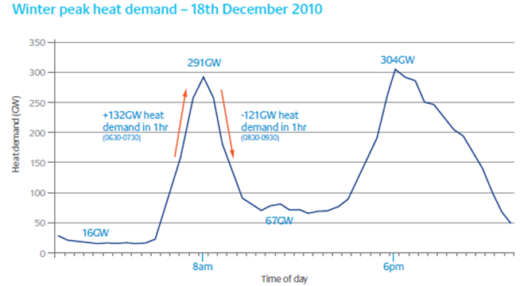

Figure 2‑3: The UK winter peak heat demand profile (Energy Technologies Institute, 2015)

Thus, hydrogen has great potential as a low carbon energy vector. It can be used as a direct replacement for natural gas or used in fuel cells or turbines to produce power. Hydrogen can be produced by electrolysis of water or by reformation of fossil fuels. Hydrogen is uniquely positioned to unlock the potential of constrained renewable energy generation, create a new storage and transport vector and enable a transition from fossil fuels.

Electrolysis uses electrical energy to split apart water molecules to produce hydrogen and oxygen. With respect to decarbonising, the source of electricity is important. There is no environmental benefit in generating hydrogen from an electrolyser powered by electricity from fossil fuels. Electrolysers provide significant added benefit to renewable generation that is constrained. When there is ample resource but insufficient demand or export infrastructure then electrolysers provide a solution where excess power can be stored and/or exported in the form of hydrogen.

Current technology for the bulk manufacture of hydrogen takes the form of fossil fuel reformation. Natural gas is often the feedstock in a process known as Steam Methane Reformation (SMR) although coal gasification can also produce hydrogen. Reforming separates the combustion reaction and the energy provided from the carbon emissions. Methane (CH4) is converted in the reformer into separated streams of hydrogen and carbon dioxide, so to reduce emissions Carbon Capture and Storage (CCS) is required to abate the CO2 emissions.

While renewable energy generation has helped to decarbonise power generation, as shown above, heat and transport make up most of our energy use. In the UK and much of Northern Europe many homes are connected to the gas grid with fuel being provided directly into a home boiler. Studies have been carried out that investigate the feasibility of utilising this existing infrastructure to deliver hydrogen instead of natural gas.

The Leeds Citygate project, H21, for example in the UK, proposes that local gas grids be converted to 100% hydrogen supplied by steam methane reformers. To convert to hydrogen would require every household boiler and stove burner to be converted to burn hydrogen instead of natural gas. The alternative is to convert to electric heating systems, which would require upgrades to both the distribution network and generation capacity, along with major changes to homes to move from a gas-based system to an electrical heating system.

The UK government has recognised the potential of hydrogen as a low carbon energy vector. In the Clean Growth Strategy hydrogen plays a key role in enabling decarbonisation of heat recognising that important strategic decisions on the future of existing infrastructure need to be made.

All North Sea countries have similar commitments to reduce emissions from transport, heat and power generation. Each presenting the slightly different strategic and policy drivers to ensure that change happens, depending on the countries specific circumstances.

In the Netherlands the government has presented a long-term energy plan that stipulates that no new cars with combustion engines may be sold from 2035 onwards. In addition, the government has indicated that by 2050 domestic heating will no longer be fueled by natural gas.

Germany has an ambition to be the first country in the world with a nationwide hydrogen refuelling infrastructure and is focused on the production of hydrogen from renewables. In addition, the country is pioneering the concept of power to gas (P2G) with the production of hydrogen from renewables, being injected into the gas grid. The German Government, along with the science and industry sectors, supports the development of fuel cell and hydrogen technologies in Germany in the form of a strategic alliance known as the National Hydrogen and Fuel Cell Technology Innovation Programme (NIP).

In Denmark, the Danish Partnership for Hydrogen and Fuel Cells is an organisation that brings together Danish manufacturers, research institutions, network organisations and public authorities under a common goal – promoting hydrogen and fuel cells in Denmark. The members deal with all aspects of hydrogen and fuel cells. Therefore, they have great interest in getting the technology developed such that hydrogen and fuel cells can compete as an energy technology in the market for alternative energy.

With the significant potential of renewables and the importance of natural gas production, Norway sees hydrogen as an important part of the future energy transition. In transport, Norway has had high take up of battery electric vehicles and its geography and population density make the development of hydrogen infrastructure a challenge; its hydrogen refuelling stations are currently focused around Oslo. Marine transport is a major area of interest given Norway’s shipping heritage as is the production of hydrogen from natural gas.

Thus, hydrogen is expected to become an important energy vector for transport, heat and power across the North Sea region, as well as in its traditional role as chemical feedstock.

The pathway to decarbonisation by utilising hydrogen will begin with technologies that are available and being developed today. Electrolysers will enable us take advantage of constrained renewables. Hydrogen fuel cell vehicles are entering the market and through synthetic fuels development, high energy density requirements like shipping and air transport can also be addressed. Hydrogen fuelled combined heat and power (CHP) will begin to supply and decarbonise industry providing low to high grade heat as well as electricity. Chemical feedstocks such as methanol and its derivatives will be decarbonised with the use of hydrogen from renewables rather than reformation.

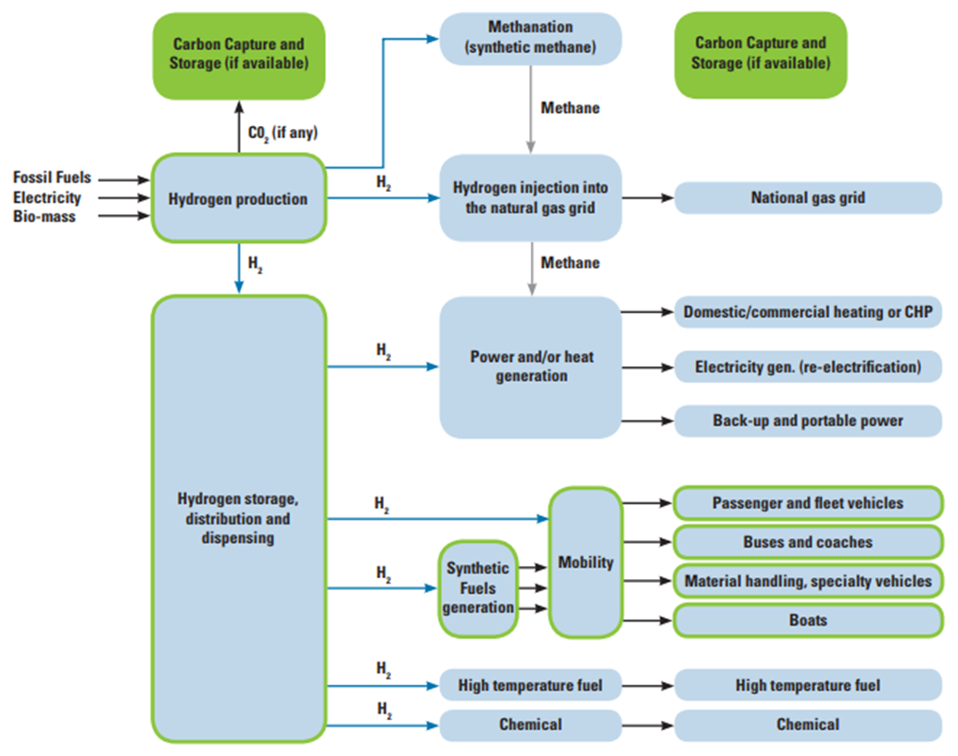

Figure 2‑4: Hydrogen production storage and use (Aberdeen City Council, 2015)

The hydrogen sector stands to become an important part of the energy mix going forward. With a growing population and an increasing demand for energy there is a significant opportunity in hydrogen technology, as well as for the supply chain that will support it. The key to unlocking the hydrogen opportunity for the supply chain is to understand where existing capability can be expanded, with minimal effort, to include hydrogen and raising awareness for companies that are not specialist hydrogen technology providers but have complimentary skill sets.

**Hydrogen Council Vision**

Hydrogen can play seven vital roles to meet the challenges of the energy transition (Hydrogen Council, 2017):

* + - 1. Enabling large-scale renewable energy integration and power generation
      2. Distributing energy across sectors and regions
      3. Acting as a buffer to increase energy system resilience
      4. Decarbonizing transportation
      5. Decarbonizing industrial energy use
      6. Helping to decarbonize building heat and power
      7. Providing a clean feedstock for industry.

The roadmap for hydrogen uptake developed by the Hydrogen Council envisages that by 2050 18% of energy demand will be hydrogen based, 6GT of CO2 will be abated annually, sales of hydrogen and equipment will reach $2.5 trillion and 30 million jobs will be created. This vision includes more than 400 million hydrogen powered cars, 15 to 20 million trucks, and around 5 million buses, which constitutes around 20-25% of their respective transportation segments. One quarter of passenger ships and a fifth of locomotives will be hydrogen powered and hydrogen based synthetic fuels will power airplanes and freight ships. The Hydrogen Council vision sees hydrogen supplying around 10% of global heat demand. In industry, hydrogen will be used for heat processes where electrification is not an efficient option. Hydrogen will become a renewable feedstock for 30% of methanol production and 10% of steel production.

# The Hydrogen Supply Chain

## Background

A number of national and international hydrogen roadmaps have been developed identifying the progression of hydrogen applications over time and these are listed in Section 6.0. These show massive growth in hydrogen production and use, across a diverse range of sectors, largely stimulated by the low carbon transition. Whilst specialist providers are aware of the opportunity this growth presents, other providers may not have yet recognised the potential supply chain opportunity. Given the long-term nature of this growth, stimulating the supply chain also includes initiating and growing training and development opportunities in hydrogen related areas, developing technologies for future commercialisation and supporting the creation of new entrepreneurial businesses with innovative solutions.

This report seeks to outline a generic hydrogen supply chain and provide a breakdown of that supply chain in order that those with potential interest can see where their skills and capabilities could be applied. The supply chain has been broken down into the logical sequence of; hydrogen production/conversion, transport of hydrogen, hydrogen storage and hydrogen use in both transport applications and non-transport applications.

Opportunities for the North Sea region supply chain are considered to be national and international and not limited to just HyTrEc2 projects within the region. Any North Sea region, or EU member could apply a similar methodology and much of the same material to explore ways to engage and develop their own regional supply chains.

## Non-transport applications

Whilst the focus of this work is the hydrogen supply chain for ‘transport’, there are many reasons to consider wider non-transport applications in this work, to maximise the potential for supply chain engagement and maximise growth of transport applications. The reasons for including non-transport applications are;

* The supply chain crosses applications. In a mature sector, most aspects of the hydrogen supply chain will support transport and non-transport aspects. For example, the electrolysis or storage supply chains are common to multiple applications.
* Maximising supply chain engagement; It is important for supply chain companies to be made aware of the breadth of hydrogen applications, in order that they can a. appreciate the volume of activity and b. identify specific areas where their capabilities can be best applied.
* Increasing activity levels will reduce costs; By considering a wider variety of applications beyond transport, the supply chain will mature at a greater rate and in doing so costs for products and services will fall as volumes increase and standardised approaches develop.

Therefore, to ensure the supply chain has an awareness of the wide variety of applications, the supply chain structure developed also outlines, at a high level, the potential hydrogen uses beyond transport. This includes the potential for increased hydrogen volumes for domestic and industrial heat, power generation and chemical feedstock. For some supply chain companies, these applications may provide opportunities which do not exist in transport applications.

Hydrogen production from all technologies is considered, whilst recognising that most transport applications may use hydrogen from electrolysis. Other applications are likely to be focused on alternate production technologies. Likewise, with transport and storage of hydrogen, whilst transport uses may focus on small to medium scale, uses in heat and power may require larger scale storage options which have been included.

## Generic hydrogen supply chain summary

Figure 3‑1 shows the hydrogen supply chain map and is broken down into the logical steps of:

* Hydrogen production and conversion by different options;
* Moving hydrogen by various means;
* Storage of hydrogen at various scales;
* Hydrogen transport applications;
* Non-transport applications;
* Hydrogen support services.

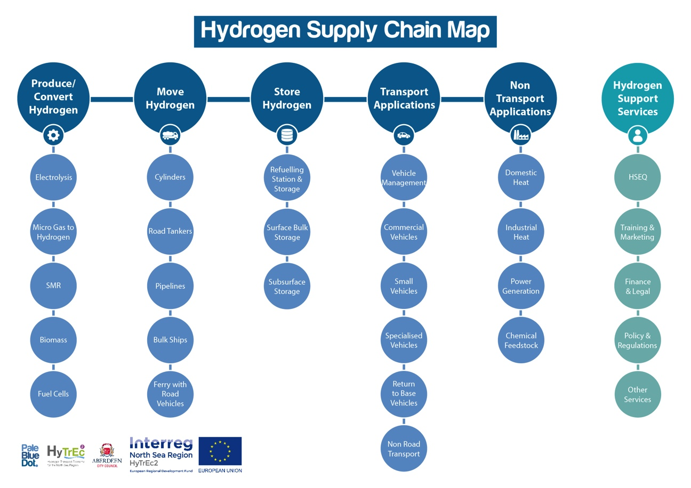

Figure 3‑1: Supply Chain Map (Pale Blue Dot Energy, 2018)

## Hydrogen supply chain elements

A summary of each of the supply chain elements is provided below.

|  |  |  |  |  |
| --- | --- | --- | --- | --- |
| **Produce/Convert Hydrogen** | | | | |
|  | Electrolysis | | | |
|  |  | Electrolysis is the process of producing hydrogen from water by applying an electric current. The process provides a means of storing energy from electrical power in the form of hydrogen. There are various electrolysis technologies available in commercial form and many areas of R&D. Supply chain aspects include the development and manufacture of electrolysers and project installations of all sizes. Electrolysis is fundamental to the hydrogen market and is used to generate hydrogen at the two refuelling stations in Aberdeen. Power supply could be from the grid or a direct connection to a renewable power source. | | |
|  | Micro Gas to Hydrogen | | | |
|  |  | Hydrogen can be manufactured from natural gas on site, using membrane or small-scale steam methane reforming (SMR) technology. This technology releases CO2 so is not considered low carbon. Technology is available now, but this is also an area of R&D. | | |
|  | Steam Methane Reforming (SMR) | | | |
|  |  | The production of hydrogen by steam methane reforming natural gas has been the usual way of making hydrogen for application in the refining process, which has been its main application for many decades. The process is generally considered to be the lowest cost means of producing hydrogen. The process generates CO2 as a waste product and thus, without CCS (below), the hydrogen produced is not low carbon. The process produces bulk hydrogen and is therefore only suitable for applications or regions with high demand for hydrogen. Further clean-up of the produced hydrogen may be required prior to use in fuel cell applications such as transport. SMR hydrogen is likely to be key to wider hydrogen deployment especially for heat and to reduce the cost of hydrogen for transport. | | |
|  | Carbon Capture & Storage (CSS with SMR) | | | |
|  |  | Carbon capture and storage (CCS) is the process by which CO2 emissions, in this case from the SMR, are captured, transported and permanently sequestered deep underground. The technology is proven in many projects around the world, including two projects in Norway. There are several projects in the design phase in the UK but none yet in operation. CCS is key to producing low carbon hydrogen from gas and is likely to be a major future market. The oil and gas supply chain is well placed to deliver CCS projects. | | |
|  | Biomass/Anaerobic Digestion (AD) | | | |
|  |  | Biogas can be produced by the anaerobic digestion of biomass such as crops, farm waste or municipal waste. The methane can then be converted into hydrogen. Alternatively, the biogas can be used for heat and/or power or injected into the gas grid. Biogas is usually produced at small to medium scale on farms or municipal plants. The process is well proven and in use in many areas. | | |
|  | Fuel Cell Applications | | | |
|  |  | Fuel cells generate electrical power from hydrogen. Fuel cell applications come in a wide variety of types and scale and all are included here under one supply chain heading. These include fuel cells for transport applications, stationary fuel cells for power (main or back up supply), small scale CHP and large fuel cells for power/CHP. The fuel cell supply chain element includes R&D, design and production of fuel cells and the subsequent installation of fuel cells, principally considering stationary applications. Hydrogen fuel cells have an important role in decarbonising heat and transport, in addition to electrical power generation. Fuel cells are fundamental to the hydrogen market. Fuel cells at all scales are commercially available, but it is also an area of R&D and product development.  Doosan Babcock is installing three of its 460 kWe Purecell systems in the new Aberdeen Exhibition Conference Centre. When completed this will be the largest fuel cell installation in the UK and similar to the largest in Europe. The system will be hybrid combined cooling, heating and power installation and will be fuelled by mains gas and biogas. | | |
| **Move Hydrogen** | | | | |
|  | Cylinders | | | |
|  |  | Hydrogen can be compressed and transported in cylinders of various sizes. This is the most common approach currently used in the Aberdeen region for delivery of hydrogen to oil and gas businesses for use in specialist welding. The approach could be used to enable wider application such as fork lift trucks and an increased market is dependent on such growth. | | |
|  | Road Tankers | | | |
|  |  | Hydrogen can be transported in two types of road tankers; tube trainers carrying compressed hydrogen in a series of horizontal cylinders or liquid hydrogen in a refrigerated tanker. Road tankers will become increasingly important as the hydrogen market develops, to move hydrogen from the point of production to the point of use. Both transport technologies are well proven. Increased market activity is dependent on increased deployment of hydrogen. | | |
|  | Pipelines | | | |
|  |  | When hydrogen volumes become very large then a pipeline is the most cost-effective means of transport. Hydrogen transport by pipeline has been standard practice on refinery sites for many decades. There is considerable activity currently ongoing exploring the potential for injecting hydrogen into the gas grid at concentrations of up to 10% or possibly 20%. In the longer term potential exists for 100% hydrogen supply to replace natural gas for heat. Three UK projects are currently evaluating this, which will involve the production and pipeline transport of 100% hydrogen (H21 Leeds, Cadent Liverpool-Manchester and Acorn Aberdeenshire) and several other projects are developing trials to explore hydrogen transport issues (SGN Scotland, HyDeploy Keele). Potential exists for assessing pipeline re-use, the implications of hydrogen in pipelines, pipeline design and future construction projects. | | |
|  | Bulk Ships | | | |
|  |  | It is possible to transport hydrogen by ship in bulk carriers, most likely as a refrigerated liquid. This is a new market area and is largely dependent on the emerging international market in hydrogen. Australia and Japan are exploring a project for producing hydrogen in Australia and shipping it to Japan. | | |
|  | Ferry of Road Vehicles | | | |
|  |  | In coastal areas such as Scotland and Norway, hydrogen road vehicles and hydrogen cylinders need to be transported by ferry. There is little distinct supply chain activity here (hydrogen powered ferries are addressed elsewhere), but the movement of hydrogen by ferry requires the appropriate safety training, contingency planning and appropriate permits/consents to be in place. | | |
| **Store and Deliver Hydrogen** | | | | |
|  | Refuelling Stations and Storage | | | |
|  |  | Hydrogen refuelling stations and their associated equipment and infrastructure are key to the deployment of transport applications. This supply chain element is focused on road vehicle refuelling stations but could also be considered to include future facilities for marine vessel refuelling. Refuelling stations include hydrogen generation or receiving facilities, compression, storage and dispensing facilities. This involves considerable high-pressure piping, valves, metering and associated equipment. The process involves storage and safe delivery of hydrogen at pressures of 350bar and 700bar. Aberdeen has two existing refuelling stations (Kittybrewster and Cove) and one additional site in planning (AECC). Additional refuelling stations across the UK are key to growing the hydrogen vehicle market. | | |
|  | Surface Bulk Storage | | | |
|  |  | As hydrogen applications evolve there is likely to be a need for bulk storage of hydrogen. The best approach for medium size storage is still being developed and may be site dependant. SGN are considering a project to supply hydrogen for heat to 300 homes and believe that 15T of hydrogen storage may be required, to enable effective load balancing between hydrogen generation/supply and domestic demand. As multiple projects become connected, there is potential to load balance between projects and use any connecting pipelines for storage. | | |
|  | Subsurface Storage | | | |
|  |  | The standard means of storing large quantities of hydrogen is in subsurface man-made salt caverns. This technology is well proven and in use for hydrogen and natural gas. Such storage is dependent upon regional geology as many areas do not have a suitable salt stratum. There is some R&D ongoing looking at the potential for subsurface storage in other formation types. As the hydrogen market develops there is likely to be significant need for subsurface storage. The oil and gas supply chain is well placed to support this activity. | | |
| **Transport Applications**  This supply chain theme is focused on regional deployment opportunities, rather than the design and construction of vehicles. This approach is taken because we see the region and North Sea HyTrEc2 focus being on the potential for deployment and support activities rather than the design and construction of vehicles. | | | | |
|  | Vehicle Management | | | |
|  |  | This supply chain element considers the generic aspects of vehicle management for all types of vehicle. Generic vehicle management activities include vehicle provision (lease/sale etc.) vehicle maintenance, conversion for diesel engines to run on hydrogen and opportunities arising from having vehicle operating experience | | |
|  | Commercial Vehicles | | | |
|  |  | This transport category includes a variety of predominantly private sector vehicles including; buses, coaches, vans, and haulage vehicles. The growth of bus fleets is currently dependent upon public funding for capital costs and the installation of regional refuelling stations infrastructure. Potential for coaches and haulage vehicles depends upon widespread availability of refuelling stations across the country/EU and the price of hydrogen, or legislation curtailing diesel vehicles. | | |
|  | Small Vehicles | | | |
|  |  | Small vehicles which are predominantly privately owned or in the private sector, include taxis, fleet vehicles and private cars. The growth of these categories depends upon public subsidy to increase volume and reduce purchase costs, the cost of hydrogen and the availability of refuelling stations across the country. Toyota indicate that they will promote further sales in Aberdeen once there are two refuelling stations available for cars. Specific regional initiatives could be used to support taxis and fleet vehicle transition to hydrogen. | | |
|  | Specialised Vehicles | | | |
|  |  | Specialised vehicles are required in both the public and private sectors and include vehicles such as road sweepers, fork lifts and refuse collection vehicles. Initiating vehicle trials in these areas, as ongoing in Aberdeen, is an important first step towards acceptance and growth. Potential exists to establish a fork lift trial with a private partner (some road maps show fork lifts as an early opportunity) | | |
|  | 'Return to base (RTB)' vehicles | | |
|  |  | Vehicles which usually stay within a particular region and regularly return to base may be a specific target for hydrogen vehicles. These could include emergency services vehicles and delivery vehicles. Potential exists to partner with a supermarket chain or parcel delivery company to trial and the grow a fleet of RTB vehicles. | | |
|  | Non-Road Transport | | | |
|  |  | Opportunities exist to support a wide range of non-road transport applications i.e. ship, rail and air transport. Most of these are probably less of a regional opportunity than road transport. The most interesting areas may be hydrogen powered ferries and hydrogen trains. The Orkney HySEAS III consortium partners are seeking to fund and develop a hydrogen ferry in Scotland. Hydrogen trains should be a focus area for the Scottish Government and in other countries. | | |
| **Hydrogen Support Services** | | |
|  | HSEQ | |
|  |  | Health, safety, environmental and quality related services are required to support the emerging hydrogen market. These services include professional services organisations (environmental consultants, emergency response support), technical service providers (lab services, specialist monitoring) and specialist equipment providers (measurement equipment, fire and gas equipment). Many of these services can be transferred from other sectors especially the oil and gas sector. |
|  | Finance, Legal | |
|  |  | Finance and legal support services are generally professional services organisations which support multiple sectors but may have specialist sector teams/individuals. |
|  | Training, Marketing | |
|  |  | The development of training courses across a wide range of hydrogen related topic areas is critical to the development of the hydrogen sector in any particular region. This should include university undergraduate and post graduate activity and R&D, college courses for technical staff, and shorter industry courses. Engagement with universities, colleges and private sector training organisations is an immediate opportunity. Separately there is a significant effort required to engage local agencies, industry, and other stakeholders in the opportunities presented by hydrogen and to engage the wider public. Investment in stakeholder engagement is an important early activity. |
|  | Policy, Regulation | |
|  |  | Given the emerging nature of the hydrogen sector, there is both a need to understand and an opportunity to influence policy, regulations and standards. Supply chain opportunities include provision of advisory services, R&D and testing activity, lobby and policy development activity and support for public funding applications. |
|  | Other Services | |
|  |  | ‘Other services’ is a catch all for support services which have not already been included above. These include logistics, IT, instrumentation etc. Many of these services will not be hydrogen specialists, but still have an important role to play in the hydrogen supply chain. |
| **Non-Transport Applications** | | |
|  | Domestic Heat | |
|  |  | As indicated elsewhere in this report, heat represents around 50% of the UK & North Sea region energy consumption and is currently largely provided by fossil fuel. Hydrogen provides a huge opportunity for decarbonising heat, by using it as a low carbon alternative to natural gas in the gas system. There is considerable activity currently ongoing exploring the potential for injecting hydrogen into the gas grid at concentrations of up to 10%. In the longer-term potential exists for 100% hydrogen supply to replace natural gas for heat.  Three UK projects are currently evaluating this, which will involve the production and pipeline transport of 100% hydrogen (H21 Leeds, Cadent Liverpool-Manchester and Acorn Aberdeenshire) and several other projects are developing trials to explore hydrogen transport issues (SGN Scotland, HyDeploy Keele). |
|  | Industrial Heat | |
|  |  | Essentially, in common with domestic heat, industrial heat is currently provided mainly by fossil fuels. The use of hydrogen provides considerable opportunity to decarbonise industry. Hydrogen creates an opportunity for industry to utilise renewable power at scale, by making and storing hydrogen in bulk. It also creates opportunity for decarbonised gas i.e. hydrogen from natural gas. The Cadent Liverpool – Manchester project has an industrial focus. |
|  | Power Generation | |
|  |  | Hydrogen can be used for power generation. As described above this could be via hydrogen fuel cells at a variety of scales and with or without a heat component. Hydrogen can also be used to drive a gas turbine in the same way as a CCGT is used as a power station, supplying the grid. Hydrogen gas turbines are in use and technology development is also ongoing. A hydrogen combined cycle gas turbine (CCGT) plant has no material CO2 emissions. It would be possible to manufacture hydrogen from natural gas using an SMR with CCS so that the SMR/CCS plant are in a different location to the power plant. |
|  | Chemical Feedstock | |
|  |  | Hydrogen has long been used as a chemical feedstock in refinery processes and has up to now been its main use. In the context of the emerging hydrogen economy two specific opportunities should be outlined, ammonia and methanol.  **Ammonia:** Ammonia has the potential to be used as an ‘energy storage’ medium or a chemical feedstock/intermediary for synthetic fuel or fertiliser. It can be made by combining hydrogen with nitrogen using the Haber Bosch process. Ammonia has the potential to be a useful means to store hydrogen energy and can be used directly to fuel internal combustion engines. Ammonia has the potential to be a significant market. |
|  |  | **Methanol and other synthetic fuels**: by combining hydrogen with CO2 it is possible to produce methanol and other synthetic hydrocarbon fuels. The process requires energy and is considered a form of Carbon Capture and Utilisation (CCU). CCU is gaining favour as an emerging area of chemical industry growth and a potential means to limit CO2 emissions from certain sources. Carbon Recycling International are an Icelandic company with this technology. |

Table 3‑1: Hydrogen supply chain elements

## Generic hydrogen supply chain detail

The table below breaks down the generic hydrogen supply chain summary into further detailed delivery components:

|  |  |  |
| --- | --- | --- |
| **Produce/Convert Hydrogen** | | |
|  | Electrolysis | |
|  |  | System Design and Tier 1 Contractor |
|  |  | Electrolysis Research and Development |
|  |  | Electrolyser design, build, supply |
|  |  | Water supply and quality |
|  |  | Electrical supply and connections |
|  |  | Civils and Site Work |
|  |  | Hydrogen metering |
|  |  | Fire and Gas Systems |
|  |  | Operations and Maintenance |
|  | Micro Gas to Hydrogen | |
|  |  | System Design and Tier 1 contractor |
|  |  | Unit design, build, supply |
|  |  | Gas supply and connections |
|  |  | Civils and Site Work |
|  |  | Hydrogen metering |
|  |  | Fire and Gas Systems |
|  |  | Operations and Maintenance |
|  | Steam Methane Reforming (SMR) | |
|  |  | Plant Design and Tier 1 Contractor |
|  |  | Consents, permits |
|  |  | Procurement |
|  |  | Construction |
|  |  | Civils and site Work |
|  |  | Balance of Plant |
|  |  | Fire and Gas systems |
|  |  | Utilities |
|  |  | Gas supply and management |
|  |  | Water supply and steam generation |
|  |  | Hydrogen clean-up of impurities |
|  |  | Hydrogen metering |
|  |  | Operations and Maintenance |
|  | Carbon Capture & Storage (CSS with SMR) | |
|  |  | Concept and Tier 1 contractor |
|  |  | Plant Design and Engineering |
|  |  | SMR/CCS integration |
|  |  | Consents, permits |
|  |  | Procurement |
|  |  | Construction |
|  |  | Civils and site Work |
|  |  | Balance of Plant |
|  |  | Fire and Gas systems |
|  |  | Utilities |
|  |  | Operations and Maintenance |
|  |  | Capture Facilities |
|  |  | CO2 transport |
|  |  | Well construction |
|  | Biomass/AD | |
|  |  | Plant Design and Tier 1 contractor |
|  |  | System design |
|  |  | Consents, permits |
|  |  | Procurement |
|  |  | Construction |
|  |  | Civils and site Work |
|  |  | Fire and Gas systems |
|  |  | Utilities |
|  |  | Feedstock supply, storage & handling |
|  |  | Waste supply & management |
|  |  | Hydrogen processing |
|  |  | Hydrogen metering |
|  |  | Operations and Maintenance |
|  | Fuel Cell Applications | |
|  |  | System Design and Tier 1 contractor |
|  |  | Fuel Cell Research and Development |
|  |  | Fuel cell design, build, supply |
|  |  | Electrical supply & connections |
|  |  | Site construction/installation |
|  |  | Hydrogen Metering |
|  |  | Fire and gas systems |
|  |  | Heat integration |
|  |  | Operations and Maintenance |
| **Move Hydrogen** | | |
|  | Cylinders | |
|  |  | Design/Manufacture/Sales |
|  |  | Delivery/Collection (Milkround) |
|  |  | System Integration |
|  |  | Sales and Orders |
|  |  | Domestic Sales (Propane Replacement) |
|  | Road Tankers | |
|  |  | Ownership/Industrial gas supply |
|  |  | Specialist tanker manufacture |
|  |  | Pipes and Fittings |
|  |  | Transfer equipment |
|  |  | Metering |
|  | Pipelines | |
|  |  | Materials and Metallurgy |
|  |  | Construction |
|  |  | Design, flow assurance |
|  |  | Network owner/transporter |
|  |  | Operations and Maintenance |
|  |  | Large scale compression |
|  |  | Gas Blending |
|  | Bulk Ships | |
|  |  | Ship design, construction, ownership, financing |
|  |  | Hydrogen international trading |
|  |  | Loading - offloading facilities |
|  |  | Storage |
|  |  | Compression |
|  |  | Interface design |
|  | Ferry of Road Vehicles | |
|  |  | Emergency Response Training |
|  |  | Hydrogen transport permits and consents |
| **Store and Deliver Hydrogen** | | |
|  | Refuelling Stations and Storage | |
|  |  | Design and Tier 1 contractor |
|  |  | Storage Tanks and Vessels |
|  |  | Pipes and Fittings |
|  |  | Compression |
|  |  | High pressure dispensing systems |
|  |  | Bulk unloading |
|  |  | QA of hydrogen on arrival |
|  |  | Operations and Maintenance |
|  |  | Metering |
|  |  | Civil Works |
|  | Surface Bulk Storage | |
|  |  | Concept and Tier 1 contractor |
|  |  | Facilities Design |
|  |  | Metering |
|  |  | Operations and Maintenance |
|  |  | Civils and Site Works |
|  |  | QA/QC of hydrogen entering/leaving |
|  |  | Storage ownership/balancing service |
|  |  | Safety management |
|  | Subsurface Storage | |
|  |  | Concept and Tier 1 contractor |
|  |  | Subsurface Design |
|  |  | Pipeline Interface |
|  |  | Metering |
|  |  | QA/QC of hydrogen entering/leaving |
|  |  | Operations and Maintenance |
|  |  | Compression |
|  |  | Salt Cavern construction |
|  |  | Well design & construction |
|  |  | Civils and Site Works |
| **Transport Applications** | | |
|  | Vehicle Management | |
|  |  | Vehicle provision |
|  |  | Vehicle maintenance |
|  |  | Vehicle conversion to hydrogen |
|  |  | Vehicle operating experience |
|  | Commercial Vehicles | |
|  |  | Buses/Coaches |
|  |  | Vans |
|  |  | Haulage vehicles |
|  | Small Vehicles | |
|  |  | Taxis |
|  |  | Private Cars |
|  |  | Fleet Vehicles |
|  | Specialised Vehicles | |
|  |  | Road Sweepers |
|  |  | Fork Lifts |
|  |  | Refuse Collection | |
|  | 'Return to base RTB' vehicles | |
|  |  | Emergency services |
|  |  | Delivery vehicles |
|  | Non-Road Transport | |
|  |  | Cargo Vessels |
|  |  | Cruise ships |
|  |  | Ferries |
|  |  | Trains/trams |
|  |  | Aeroplanes/helicopters |
| **Hydrogen Support Services** | | |
|  | HSEQ | |
|  |  | Handling high pressure gas |
|  |  | Emergency management/response |
|  |  | Carbon emissions analysis |
|  |  | Measurement of impurities |
|  |  | Fire and Gas detection |
|  |  | Regulations expertise |
|  |  | Environmental Impact Assessments |
|  | Finance, Legal | |
|  |  | Risk analysis |
|  |  | Economics, Business case |
|  |  | Insurance |
|  |  | Banks, private equity |
|  |  | Legal advisors |
|  |  | Strategic advisors |
|  |  | Cost/planning |
|  | Training, Marketing | |
|  |  | Undergraduate/graduate courses |
|  |  | Research/Phd/Post doctoral activity |
|  |  | College courses for technicians |
|  |  | Industry courses for technical staff |
|  |  | Introduction to hydrogen courses |
|  |  | Recruitment Agencies |
|  |  | Hydrogen Market assessments |
|  |  | Public awareness/stakeholder/marketing support |
|  | Policy, Regulation | |
|  |  | Hydrogen standards |
|  |  | R&D/testing to inform policy |
|  |  | Lobby and policy development |
|  |  | Public funding support |
|  |  | Hydrogen regulation and development |
|  | Other Services | |
|  |  | Logistics |
|  |  | IT/communications |
|  |  | Electrical/Mechanical services |
|  |  | Instrumentation/process control |
|  |  | Lifting and handling |
| **Non-Transport Applications** | | |
|  | Domestic Heat | |
|  |  | Boiler replacement/burner changes |
|  |  | High pressure hydrogen supply |
|  |  | Low pressure gas grid conversion |
|  |  | Health and Safety |
|  |  | Blending H2 into NTS |
|  | Industrial Heat | |
|  |  | High pressure hydrogen supply |
|  |  | Low pressure pipeline conversion |
|  |  | Industrial application conversions |
|  |  | Health and Safety |
|  |  | Blending hydrogen into NTS |
|  | Power Generation | |
|  |  | Hydrogen small scale CHP |
|  |  | Hydrogen large scale CHP |
|  |  | Hydrogen gas turbines CCGT |
|  |  | System integration |
|  | Chemical Feedstock | |
|  |  | Synthetic fuels |
|  |  | Refinery feedstock |
|  |  | Ammonia/methanol production |
|  |  | CO2 utilisation technologies |

Table 3‑2: Generic hydrogen supply chain

# Hydrogen Supply Chain Growth

## Supply chain growth

Supply chain companies in the private sector generally react to market forces. Near term opportunities drive more immediate action, as a wide range of staff can see the potential. The following levels of market certainty will drive action with a decreasing level of stimulus;

* + - 1. Near term multiple projects
      2. Single flagship project
      3. Sector road map
      4. Sector vision

However, in an emerging market, having a clear vision and road map is important to provide an indication of market opportunities, whilst projects may come later.

There are four principal ways to grow the hydrogen supply chain in a region:

* + - 1. Grow existing regional hydrogen supply chain businesses
      2. Diversify existing regional companies into hydrogen
      3. Bring existing hydrogen players to the region
      4. Stimulate new hydrogen businesses in the region

The growth of new hydrogen businesses could be viewed as a longer-term strategy to increase the supply chain, which in the context of an emerging hydrogen market and long-term transition remains an appropriate strategic approach.

The approach for engaging - and hence supporting - supply chain growth of each of the four groups is different. They are each addressed below.

## Grow existing regional hydrogen businesses

Supply chain businesses already in the region and active in hydrogen should be engaged and supported carefully whist ensuring other companies, which may be competitors, can also grow. A regional hydrogen vision and strategy is a valuable way of communicating with such organisations and if such a vision or strategy does not already exist then consider engaging with existing hydrogen businesses to develop them. This process can include consideration of future projects as well as longer term objectives.

Since supply chain opportunities arise from projects, stimulating projects and having clear customers/Tier 1 contractors to lead them, are key to delivering real activity.

## Diversify regional companies into hydrogen

For existing supply chain companies to engage in the hydrogen supply chain, they need to have;

* An awareness of the potential which hydrogen offers
* A willingness to explore this potential and
* A willingness to change

National and regional bodies have a role to support the increase in awareness of the hydrogen opportunity. Organisations must look internally for the willingness to explore this potential and a willingness to change.

A typical diversification journey follows three phases;

* Preparatory work
* Strategic assessment
* Delivery

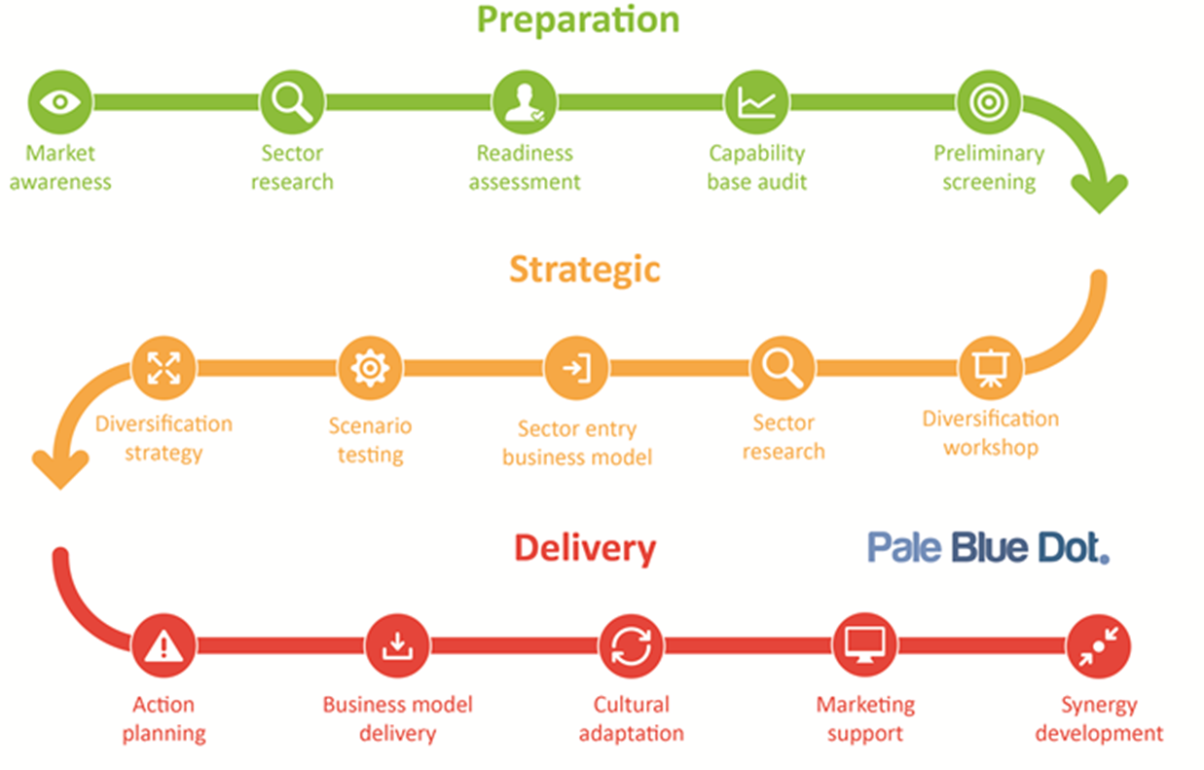

Figure 4‑1: Diversification pathway (Pale Blue Dot Energy, 2016)

More detailed factors affecting supply chain engagement include (in no particular order)

* Strategic fit (Hydrogen fit with corporate strategy, short term ability to access market, cost of entry, need for product/service development, long term potential)
* Hydrogen market (understanding, activity, potential market, location, competition, specific opportunities)
* Labour force (existing and potential hydrogen market related; skills, education, training, local capability, transferable skills, cost base)
* Technology, services or products for the hydrogen market; (Products, innovation, new technologies, manufacturing processes)
* Hydrogen supply chain interactions (prime contractors and tier 1 buyers, competitiveness both local vs national and national vs global)
* Government position on hydrogen (future programmes, policy, local policy, regional policy, vision/role of hydrogen, regional/local funding, planning)
* Financial aspects of hydrogen business (market maturity, commercial models, economics, revenue, profitability)

## Bring existing hydrogen players to the region

Creating a ‘hydrogen region’, with a vision and strategy for a significant hydrogen supply chain, should help attract existing hydrogen players to the region. Other more direct action may be required, including stipulating a local presence during project delivery, if selected contractors are based elsewhere.

## Stimulate new businesses in the region

As the hydrogen market grows, opportunities will emerge for new start businesses. These may be based upon new technology (e.g. university spin outs), application of technology from other sectors or project/service-based offerings. The key is to provide a supportive environment in which such business start-ups can flourish.

An ideal environment could include a location within the region where there is a hydrogen cluster, bringing together hydrogen research, academia, existing hydrogen supply chain businesses and entrepreneurial businesses. By creating a location focused on hydrogen and providing support to new start-ups and SMEs, the potential exists to create a strong flow of new hydrogen businesses.

## Ideas for practical action

Listed below are several ideas for practical action to support regional hydrogen supply chain growth. They are in no particular order.

* Develop a regional vision and strategy for hydrogen, which includes the public and private sectors and includes quantified objectives to reflect the level of ambition. Include existing hydrogen supply chain companies in the process.
* Appoint one or more regional hydrogen champions to work across the public and private sectors to promote hydrogen in the region.
* Identify and assess regional strengths which could support and differentiate a particular region.
* Create and deliver tangible hydrogen projects in the region to create profile and visibility for the supply chain to see and engage with.
* Create highly branded hydrogen transport applications such as buses, taxis and trains.
* Provide support to initiate hydrogen commercial vehicles such as fork lifts, delivery vehicles and ‘return to base’ vehicle fleets.
* Explore opportunities for hydrogen fuelled shipping (cruise liners, support vessels, cargo vessels and ferries)
* Develop inter-regional partnerships to build on regional strengths, create new funding and project opportunities and address regional weaknesses. Develop EU funded projects.
* Encouraging partnering and collaboration between businesses to; link large corporate capability with SME innovation; bring corporate capability to a region; build on regional strengths and; address regional weaknesses.
* Stimulate the development of undergraduate/postgraduate university courses on hydrogen; incorporate hydrogen into other undergraduate/postgraduate courses and; promote hydrogen related research and development.
* Stimulate the development of technician and technical training programmes for hydrogen-based roles through technical training colleges and private sector organisations.
* Stimulate new hydrogen-based start-ups, entrepreneurial activity and SMEs.
* Encourage private sector hydrogen R&D activity.
* Create a location within the region where there is a hydrogen cluster, bringing together hydrogen research, academia, existing hydrogen supply chain businesses and entrepreneurial businesses.
* Provide public support to supply chain companies, through the regional development agency or other body, in areas such as; expert support programmes; diversification support; strategy development and; support for personnel training and development.
* Facilitate the arrangement of regional events and conferences on hydrogen aimed at broadening understanding and engaging the regional supply chain.

# Glossary

**AD**: Anaerobic digestion

**AECC**: Aberdeen Exhibition and Conference Centre

**CCGT**: Combined cycle gas turbine

**CCS**: Carbon capture and storage

**CCU**: Carbon capture and utilisation

**CHP**: Combined heat and power

**CO2**: Carbon dioxide

**GT**: gigatons

**H2**: Hydrogen

**HyTrEc2**: Hydrogen Transport Economy 2

**kWe**: Kilowatt (electricity)

**NIP**: National Hydrogen and Fuel Cell Technology Innovation Programme (Gernany)

**NTS**: National Transmission System

**P2G**: Power to gas

**QA/QC**: Quality assurance/Quality control

**R&D**: Research and development

**RFS**: Refuelling station

**RTB**: Return to base (vehicles)

**SGN**: Scottish Gas Networks

**SME**: Small and medium sized enterprise

**SMR**: Steam methane reforming

# References

Aberdeen City Council. (2015). *Aberdeen City Region Hydrogen Strategy & Action Plan.* H2 Aberdeen.

Energy Technologies Institute. (2015). *Smart Systems and Heat: Decarbonising Heat for UK Homes Insights Report.* Energy Technologies Institute.

Government of South Australia. (2017). *A Hydrogen Roadmap for South Australia.* Government of South Australia.

Hydrogen Council. (2017). *Hydrogen Scaling Up; A Sustainable Pathway for the Global Energy Transition.*

Scottish Government. (2015). *Energy in Scotland 2015.* Scottish Government.